[E101] Mash pump

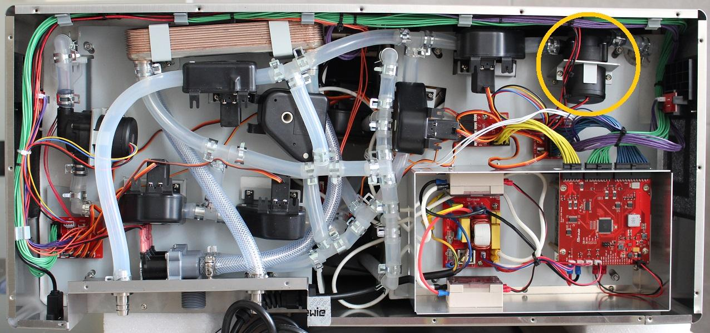

*Figure 1 Location of the mash pump in the B+*

Unscrew the screws of the pump and remove the fastening clamp.

Loosen the screws of the return valve next to the pump and move the valve from its original position in order to ease pump replacement.

Pull off the pipe clamps from the pump fittings and pull off the silicone hose from the fitting.

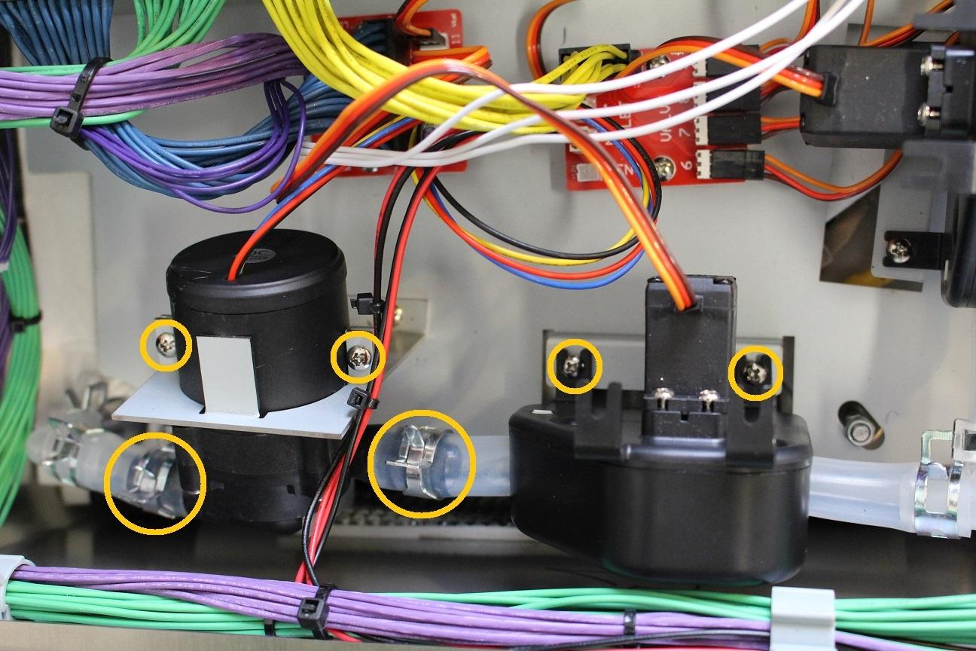

*Figure 2 Removal of the mash pump*

Disconnect the pump cable from the PCB.

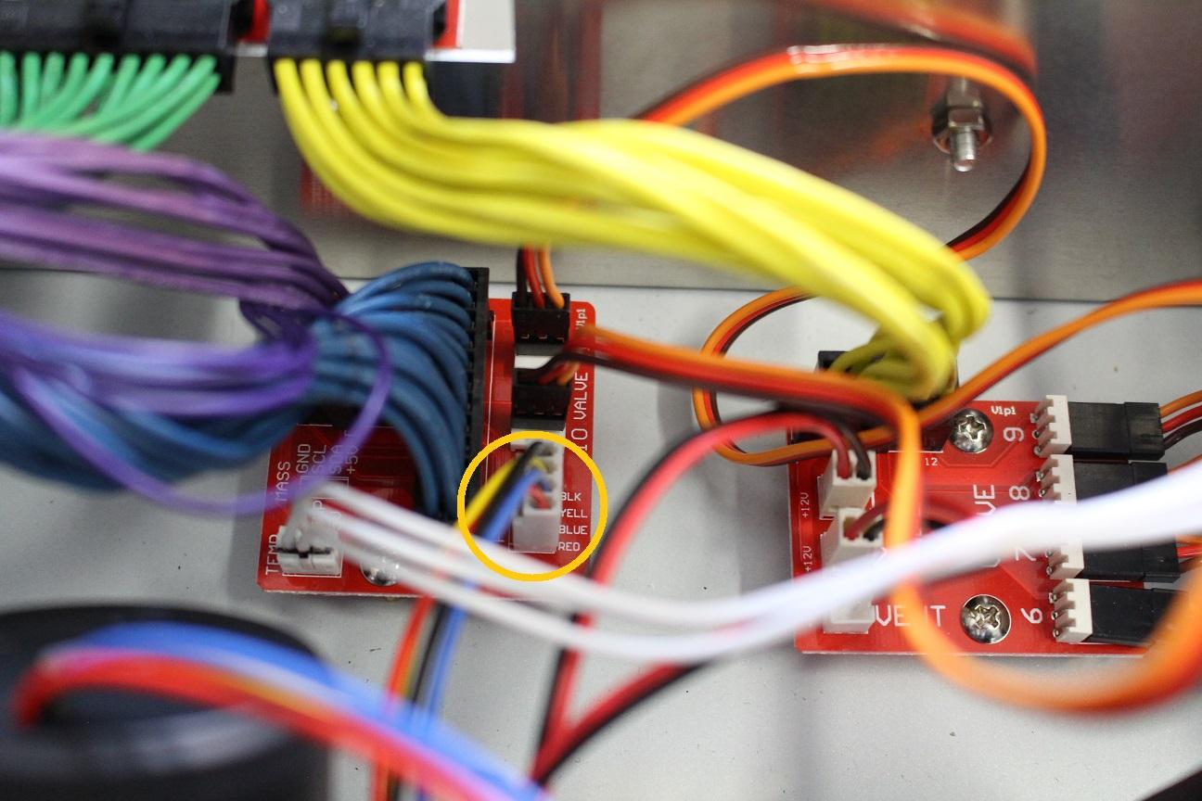

*Figure 3 Mash pump cable*

The pump is removable now.

**IMPORTANT: In all cases you check if the pumps are clogged. If the pump is clogged, replacement is not necessary, after cleaning the pump can be used.**

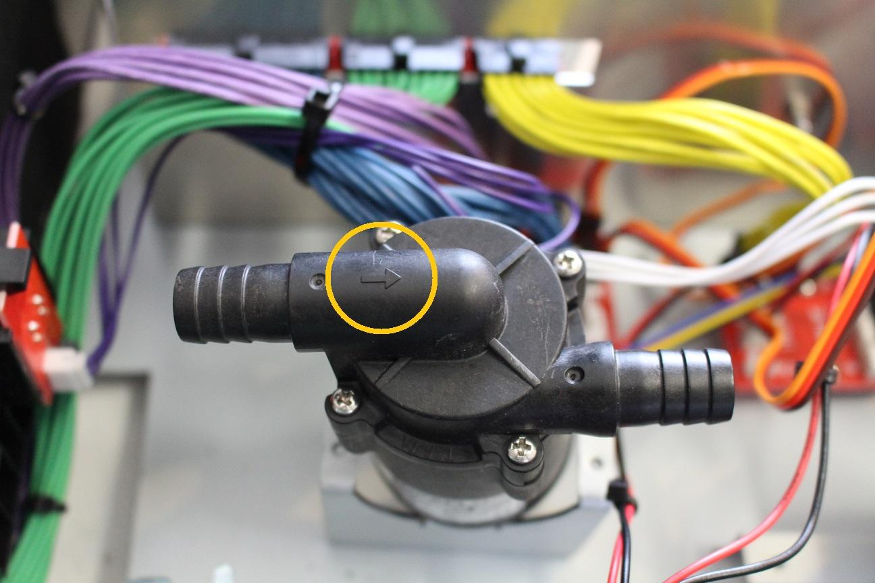

Reassemble consists of the same steps in reverse. Make sure that the pumps are in the specified angle (check if during servicing the holding metal sheet wasn’t bent) and the marked direction of the flow is appropriate. In normal operation the device pumps the water OUT of the mash tank.